
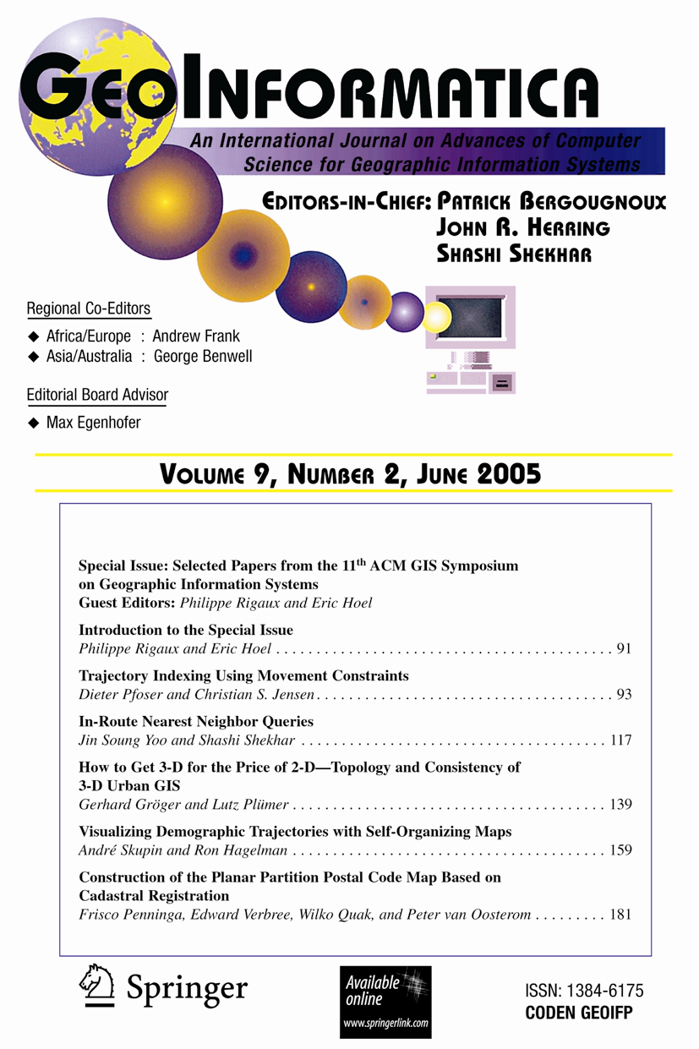
Free Access!
GeoInformatica
An International Journal on Advances of Computer Science for Geographic Information Systems
Editors-in-Chief: Patrick Bergougnoux; John R. Herring; Shashi Shekhar

ISSN: 1384-6175 (print version)
ISSN: 1573-7624 (electronic version)

GeoInformatica is located at the confluence of two rapidly advancing domains: Computer Science and Geographic Information Science; nowadays, Earth studies use more and more sophisticated computing theory and tools, and computer processing of Earth observations through Geographic Information Systems (GIS) attracts a great deal of attention from governmental, industrial and research worlds.

This journal aims to promote the most innovative results coming from the research in the field of computer science applied to geographic information systems. Thus, GeoInformatica provides an effective forum for disseminating original and fundamental research and experience in the rapidly advancing area of the use of computer science for spatial studies.

Many topics in the field of computer science involve a very specific approach in the domain of geographic information systems; coverage includes:

- Spatial Modeling
- Spatial Databases
- Human-Computer Interfaces for GIS
- Digital Cartography at the Core of GIS
- Space Imagery in GIS
- Parallelism, Distribution and Communication through GIS
- Spatio-Temporal Reasoning.

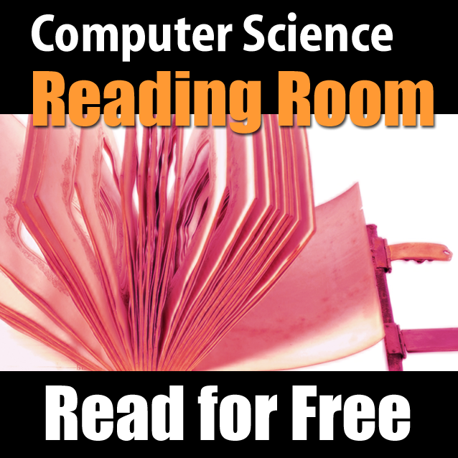
Free Access to GeoInformatica and Other Book and Journals: Become a Springer Computer Science Reader!

The Springer Computer Science Reading Room offers you free access to GeoInformatica and other books and journals in your area of interest. Joining the Reading Room is free! Just visit the below URL, select a username, password and enter your SpringerToken.

- Log in at: www.springeronline.com/readingroom
- SpringerToken: 2Q6x5N4GGPZbnp3

